2017
HOLY SPIRIT
SEAFOOD DINNER

(a.k.a. FISH FRY)

EVERY FRIDAY (except Good Friday) DURING LENT
(March 3 thru April 7)
4:30 - 7:00 P.M.

HOLY SPIRIT PARISH GYM
3120 Parkwood Lane, Maryland Hts. 739-0230
www.holyspiritstl.org

DINE-IN OR CARRY-OUT

MENU ITEMS WILL INCLUDE:

Fish Dinner $8.50 Kids $4.50
Baked Cod Dinner $8.50
Grilled Salmon Dinner $8.50
Shrimp Dinner $8.50 Kids $4.50
Spaghetti Dinner (meatless) $4.00 Kids $3.00

Dinners include 2 side dish options.

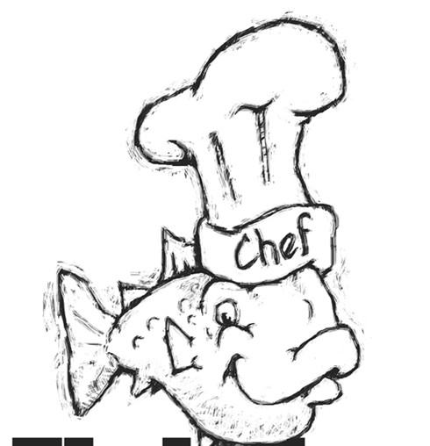
Kid’s dinner includes 1 side dish option.

SIDE DISH OPTIONS
Fries/Onion Rings
Baked Potato
Hush Puppies (3)
Green Beans
Spaghetti (meatless)
Cole Slaw
Apple Sauce
(additional sides dish $1.50)

ADDITIONAL ITEMS

Fish Sandwich $3.50
Cheese Pizza $2.00
Cheese Sticks (3) $2.00
Fish $11.50/lb.
Slaw/Spaghetti $3/pt.-- $4.50/qt.

Free drinks (coffee, tea or punch) with dine-in meals

WORKERS AND DESSERT DONATIONS NEEDED
Please call Debbie and Steve Borgmann 291-7318
steveborgmann@att.net
Please bring desserts to the kitchen on Fridays after 3pm

BACK AGAIN THIS YEAR

DRIVE THRU MENU
Fish $11.50/lb.
Fried Shrimp $10.50/Doz.
Slaw/Spaghetti $3/pt. -- $4.50/qt.
Green Beans $3/pt. -- $4.50/qt.
Fries/Hush Puppies(6 sm/9 lg) $3 small -- $4.50 large

