Holy Spirit
Vacation Bible School

June 19-23, 2017

9:00 am – 12:00pm daily

ADULT VOLUNTEER
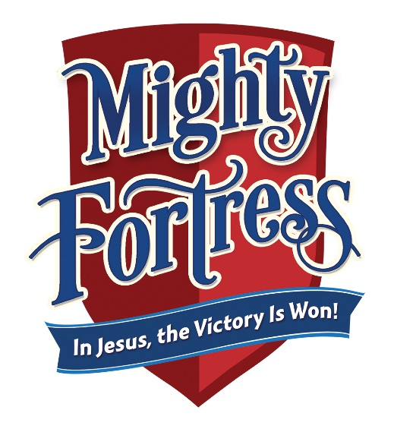
“Thanks be to God who gives us the victory through our Lord Jesus Christ.”
(1 Corinthians 15:57)

For more information, contact:

Shannon Purvis 579-9866 or shannonpurvis@hotmail.com
Denise Portman 922-9374 or deniseportman@gmail.com
Christina Block 737-6270 or christina2382@hotmail.com

RETURN TO PARISH OFFICE BY: May 15, 2017

Adult volunteer’s name: ______________________________________________

Address: ________________________________________________________________

City: ___________________________________ State: _________ Zip: ___________

Home phone number: _____________________ Cell #: _____________________

Email: ____________________________________________________________________

Emergency contact: ____________________________________________________

Emergency phone#: ____________________________________________________

I would need child/nursery care: Yes or No

Describe: ________________________________________________________________

T-shirt size (circle one) - T-shirts are provided for station leaders and volunteers in attendance all week at no charge

Adult size: S M L XL XXL

Last year I helped with: ________________________________________________

This year I would like to help with: ___________________________________

I am available (circle): M T W Th F

__________ I am Protecting God’s Children compliant

__________ I need information to become PGC compliant

