Holy Spirit
Vacation Bible School

June 19-23, 2017

9:00 am – 12:00pm daily

CAMPER – $30 per child
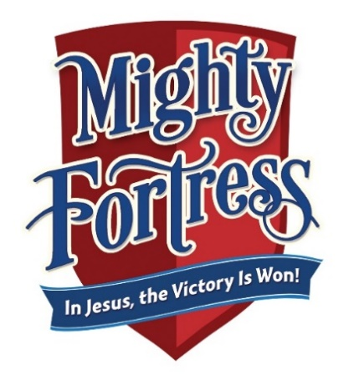
“Thanks be to God who gives us the victory
through our Lord Jesus Christ.”
(1 Corinthians 15:57)

For more information, contact:

Shannon Purvis 579-9866 or shannonpurvis@hotmail.com
Denise Portman 922-9374 or deniseportman@gmail.com
Christina Block 737-6270 or christina2382@hotmail.com

RETURN TO PARISH OFFICE BY: May 15, 2017

Child’s name: ___________________________________________________________

Birth date & year (must be 3 by Jan. 1, 2017): ______________________

Grade entering in the fall: _____________________________________________
Address: ________________________________________________________________

City: ___________________________________ State: _________ Zip: ___________

Home phone number: __________________________________________________

Email: ___________________________________________________________________

Mother’s name: ___________________________ Cell #: _____________________

Father’s name: ____________________________ Cell #: _____________________

Emergency contact: ____________________________________________________

Relationship to child: __________________________________________________

Emergency phone #: ___________________________________________________

Allergies or concerns: _________________________________________________

T-shirt size (circle one)

Child size: XS(2-4) S(6-8) M(10-12) L(14-16)

Adult size: S M

Is your family registered at Holy Spirit Parish? Y or N

Music CD – one per family included in registration

Additional CD’s __________ x $2 each = ________________

For office use only:

Paid: Cash Receipt #: _______________ or Check #: _____________

Pay Later

