Holy Spirit
Vacation Bible School

June 19-23, 2017

9:00 am – 12:00pm daily

YOUTH HELPER
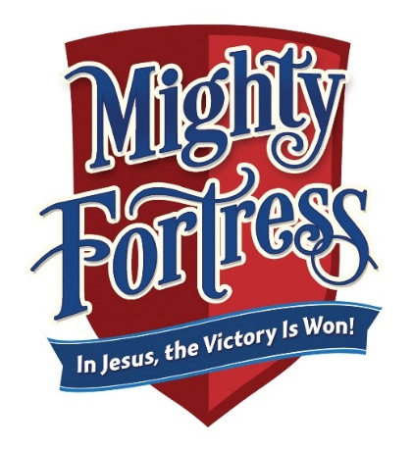
“Thanks be to God who gives us the victory
through our Lord Jesus Christ.”
(1 Corinthians 15:57)

For more information, contact:

Shannon Purvis 579-9866 or shannonpurvis@hotmail.com
Denise Portman 922-9374 or deniseportman@gmail.com
Christina Block 737-6270 or christina2382@hotmail.com

RETURN TO PARISH OFFICE BY: May 15, 2017

Youth helper’s name: __________________________________________________

Grade entering in the fall (must be 6th grade or older): ____________________

Address: ________________________________________________________________

City: ___________________________________ State: _________ Zip: ___________

Home phone number: __________________________________________________

Primary communication will be via email:

____________________________________________________________________________

Parent contact: ________________________________ Cell #: ________________

Emergency contact: ____________________________________________________

Relationship to helper: ________________________________________________

Emergency phone #: ___________________________________________________

Allergies or concerns: _________________________________________________

T-shirt size (circle one):

Adult size S M L XL XXL

Last year I helped with: ________________________________________________

This year I would like to help with: ___________________________________

__________ Attached is my signed “Code of Conduct for Minors”

Parental consent signature: ___________________________________________

